MODEL DOCUMENTATION
Annuity Valuation Model
Best Estimate Liability projection: Excel benchmark, Python engine, and Excel front-end

Document control
Item | Detail
Document title | Annuity Valuation Model: Model Documentation
Version | 1.0
Date | 7 October 2026
Model components | Annuity.xlsm, Parameters.xlsm, Python projection package
Valuation date of reference files | 31 December 2026
Model owner | Paarth Makkar
Reviewer | Paarth Makkar
Intended audience | HR and business stakeholders, actuarial analysts, students, and enthusiasts

Revision history
Version | Date | Description | Author
1.0 | 7 October 2026 | First draft of the model documentation | Paarth Makkar

1. Introduction

1.1 Purpose of this document
This document describes the Annuity Valuation Model: what it is for, how it is built, what it takes as input, how it calculates its results and how those results should be read. It is written so that a reader can follow the model from the underlying insurance concepts through to the final output files without needing to open the code or the spreadsheets, and so that a technical reader can then use it as a reference while doing so.
The model projects the future cash flows of a portfolio of immediate-style annuity policies and discounts them to produce the Best Estimate Liability (BEL), the central estimate of what the insurer expects to pay out, net of what it expects to receive, in respect of those policies.

1.2 Intended audience.
The model is documented for a mixed readership. Each group can read the document at the depth it needs.
Table 1. Audience and suggested reading path
Audience | What they will get from this document | Suggested sections
HR and business stakeholders | A plain-language view of what the model does, what it needs and what it produces, and how the work is controlled. | 1, 2, 3, 9, 10, 11
Actuarial analysts | The full calculation specification, input definitions, implementation detail in Excel and Python, and reconciliation approach. | 3 to 11, Appendix A
Students | A worked path from annuity concepts to a working projection model, with every formula stated explicitly. | 2, 4, 5
Enthusiasts | The design of the Excel benchmark, the vectorized Python engine and the Excel front-end that connects them. | 3, 6, 7, 8

1.3 How the document is organized.
The document follows the life of a model run, from concept to result:
- Sections 2 and 3 set out the insurance background and the overall design of the model.
- Sections 4 and 5 define what goes into the model and the mathematics applied to it.
- Sections 6, 7 and 8 describe the three physical components: the Excel benchmark, the Python engine, and the Excel front-end.
- Sections 9 to 11 cover outputs, controls and validation, and the known limitations.
- Appendices contain the glossary and the reference portfolio.

1.4 Conventions used
Convention | Meaning
Monospace text | A file name, sheet name, column name, function, or formula.
Blue / black text | Blue is an input cell that may be edited freely; black is a formula cell that should be left unchanged.
Greyed out cells | A run or debug selection that is switched off and will not be run.
Time t | Projection year, where t = 0 is the valuation date and each step is one year.
Amounts | Presented in the units of the input data; the Excel sheets label results as being in thousands (000s).

2. Background: Annuities and the Best Estimate Liability

2.1 What is annuity?
An annuity is a contract under which an insurer pays a policyholder a regular income, for life or for a fixed term, in exchange for a premium. The insurer takes on two uncertainties on behalf of the policyholder: how long the policyholder will live, and how investment returns and inflation will evolve over policy term. Pricing and reserving an annuity are therefore largely a question of projecting survival and discounting future payments.

2.2 Product features captured by the model.
The model represents a flexible annuity design. Each policy in the portfolio is described by a small set of features, and the combination of features determines its cash flow.
Feature | Description | How it enters the model
Premium | A single premium paid at the start of the contract. | Paid at policy duration 1 only. In-force policies (duration already above zero) have no future premium.
Annuity | The regular amount paid to the policyholder each year. | Paid every year of the policy term, scaled by an escalation index.
Term | The maximum number of years for which the annuity is paid. | Annuity, expenses, and commission stop after the term.
Guaranteed period | An initial number of years in which payments are made whether the policyholder survives. | Annuity payments in this period are not weighted by survival.
Provisional period | Payments after the guaranteed period, made only while the policyholder is alive. | Annuity payments are weighted by the probability of survival.
Escalation | Annual increase of the annuity amount, either at a fixed (level) rate or linked to RPI or CPI inflation. | Drives the annuity escalation index.
Survival benefit | A lump sum paid at the end of the term if the policyholder is still alive. | Paid when duration equals term, weighted by survival.
Expenses and commission | Costs of administering the policy and paying the distributor. | Fixed, percentage-of-premium and percentage-of-sum-assured components, by policy year.

2.3 The Best Estimate Liability
Under Solvency II, an insurer holds a liability equal to the probability-weighted present value of all future cash flows arising from its policies, using realistic assumptions and a risk-free discount curve. This quantity is called the BEL. For an annuity portfolio it is, in words:
$$BEL = PV(annuity payments) + PV(survival benefits)$$
$$+ PV(expenses) + PV(commission) - PV(premiums)$$
A positive BEL means expected outgo exceeds expected income. A negative BEL arises in new business where the premium received is larger than the discounted value of the benefits and costs that follow.

2.4 Why model stresses?
The best estimate is only one view of the future. Annuity writers are exposed primarily to longevity risk (policyholders living longer than expected) and interest rate risk. The model allows mortality and interest assumptions to be shifted by a fixed amount, by a relative proportion, or both, so that the change in BEL can be measured for each scenario (Section 4.6).

3. Model Overview

3.1 Objectives and scope
The model was built to provide a transparent, repeatable, and scalable way to value an annuity portfolio. Three design objectives drive its structure:
- Transparency. Every calculation can be inspected line by line in Excel, so a reviewer can trace any number back to its inputs.
- Scalability. The same logic is available in a vectorized Python engine that processes the whole portfolio at once, for many runs and scenarios.
- Usability. A single Excel workbook controls the assumptions, runs, and outputs, so that analysts who do not write code can operate the model.

3.2 Architecture
Figure 1 shows how the components connect. Analysts work in Parameters.xlsm; macros write the assumptions to CSV files and the run settings to a JSON file; the Python engine consumes those files and produces output workbooks; Annuity.xlsm stands alongside as an independent check.
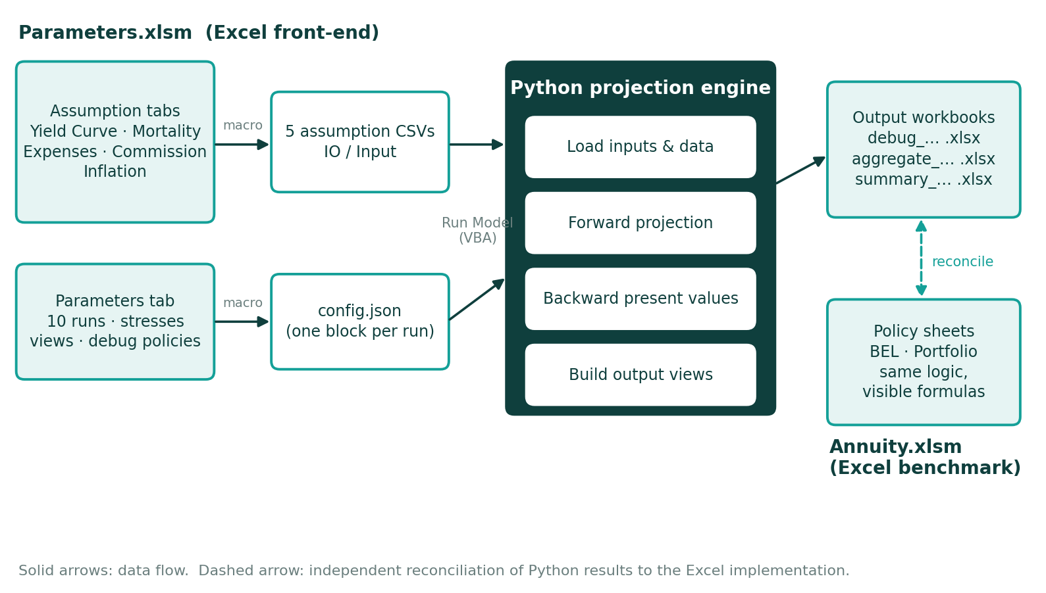
Figure 1. Model architecture and data flow.

3.3 End-to-end workflow
A typical session follows these steps:
- Update assumptions. Edit the yield curve, mortality, expense, commission, and inflation tabs in Parameters.xlsm.
- Set up runs. On the Parameters tab, switch on up to ten runs, name them, set the valuation date, projection length, and any stresses, and choose which views (debug, aggregate, summary) each run should produce.
- Export assumptions. Use the Assumption Loader buttons (or Generate CSVs) to paste each assumption tab, values only, into its CSV file.
- Export the run configuration. Use Export Config (JSON) to write the run settings to a configuration file.
- Run the model. Press Run Model. The macro launches the Python engine in its virtual environment; the engine loads the CSVs, the JSON, and the policy data, and runs each active run in turn.
- Review outputs. Open the timestamped result workbooks written to the output folder and reconciles to the Excel benchmark where required.

3.4 Scope and boundaries
Within scope | Outside scope
Projection of premium, annuity, survival benefit, expense and commission cash flows by policy and year | Pricing new business or setting of premium rates
Best estimate liability at the valuation date and its projection by time step | Risk margin, capital requirements, and solvency reporting
Mortality and interest rate stresses, applied per run | Stochastic scenarios and economic scenario generators
Policy-level, portfolio-level, and summary outputs | Reinsurance, tax, and investment asset modelling

4. Model Inputs
The model has four families of input: the policy data describing what has been sold, the economic and demographic assumptions describing the world in which the policies will run off, the stresses that adjust those assumptions, and the run parameters that control how the model is executed. Each is described in turn.

4.1 Policy data
Policy data is held as one row per policy. In the Excel benchmark it sits on the Data sheet; in the Python model it is read into a table from which the engine takes columns as vectors. Sixteen fields describe each policy.
Table 2. Policy data fields
Field | Description | Coding or notes
Policy ID | Unique identifier of the policy. | Whole number. Matches the number of the policy sheet in Excel.
Age at Start | Age of the policyholder at the start of the contract. | Years.
Premium | Single premium paid at policy duration 1. | Zero effect for policies already in force.
Annuity | Base annual annuity payment, before escalation. | Currency units per year.
Term | Number of policy years for which the annuity is paid. | A value of 100 effectively means a lifetime annuity within the projection horizon.
Duration IF | Years the policy has already been in force at the valuation date. | 0 = new business at the valuation date.
Survival Benefit | Lump sum paid if the policyholder is alive at the end of the term. | Paid when duration equals term.
Sex | Selects the male or female mortality column. | 1 = male, 0 = female.
Guaranteed Period | Years in which the annuity is paid regardless of survival. | 0 = no guarantee.
Inflation Index | Inflation series used to grow expense amounts. | 1 = RPI, otherwise CPI.
Annuity Esc Index | Basis of annuity escalation. | -1 = level rate, 1 = RPI, 0 = CPI.
Annuity Escalation | Level escalation rate. | Used only where the escalation basis is level.
Accrued Annuity Escalation | Escalation already accumulated up to the valuation date. | Initial escalation index = 1 + this value.
Accrued Inflation | Inflation had already accumulated up to the valuation date. | Initial inflation index = 1 + this value.
Expense Indicator | Switches expenses on or off for the policy. | 1 = include, 0 = exclude.
Commission Indicator | Switches commission on or off for the policy. | 1 = include, 0 = exclude.

4.2 Interest rates: the yield curve
The discount curve is provided as annual spot rate by term from 0 to 50 years. The model converts them to forward rates, the rate applicable between one year-end and the next, which are then used to discount cash flows step by step.
Forward rate
$$fwd(t) = {\left(1+spot\left(t\right)\right)}^{t}/{\left(1+spot\left(t-1\right)\right)}^{t-1}-1$$
$$fwd(0) = spot(0)$$
Table 3. Extract of the reference yield curve
Term (years) | Spot rate | Forward rate
1 | 5.98% | 5.98%
2 | 6.34% | 6.70%
5 | 6.81% | 7.37%
10 | 7.28% | 8.28%
20 | 7.96% | 9.68%
30 | 8.37% | 8.95%
50 | 8.27% | 5.85%
Terms beyond the last point on the curve use the final rate (the lookup index is clipped to the table range).

4.3 Mortality
Mortality is supplied as a table of one-year probabilities of death, q(x), by age and sex. The reference table runs from age 20 to age 115, where the male probability of death reaches 0.99999 (0.899991 for females). For lookups, the age is capped at the oldest age in the table.
Table 4. Extract of the reference mortality table, q(x)
Age | Male | Female
20 | 0.000284 | 0.000256
40 | 0.001234 | 0.001148
60 | 0.006349 | 0.005968
80 | 0.046730 | 0.043459
100 | 0.382129 | 0.359201
115 | 0.999990 | 0.899991

4.4 Inflation
Two inflation series, RPI and CPI, are provided by projection year for 0 to 50 years. They serve two purposes: growing the fixed per-policy expense amount and escalating the annuity for policies whose escalation is linked to an index. Beyond the table the last values are held.
Table 5. Extract of the reference inflation assumptions
Projection year | RPI | CPI
1 | 2.00% | 7.00%
2 | 0.00% | 2.00%
3 | 7.00% | 1.00%
4 | 3.00% | 0.00%
5 | 4.00% | 6.00%

4.5 Expenses and commission
Expense and commission assumptions are defined by policy year (1 to 6, with year 6 applied to all later years). Expenses have three components; commission has two.
Table 6. Reference expense assumptions
Policy year | Fixed amount | % of premium | % of sum assured
1 | 75 | 3.00% | 5.00%
2 | 50 | 2.00% | 2.00%
3 | 35 | 1.00% | 2.00%
4 | 30 | 1.00% | 2.00%
5 | 25 | 0.50% | 2.00%
6 | 20 | 0.50% | 2.00%
Table 7. Reference commission assumptions
Policy year | Fixed amount | % of premium
1 | 75 | 3.00%
2 | 50 | 2.00%
3 | 25 | 1.00%
4 | 25 | 1.00%
5 | 25 | 1.00%
6 | 25 | 1.00%
The fixed expense amount is inflated using the policy's inflation index; the fixed commission amount is not.

4.6 Stresses
Stresses adjust the interest and mortality assumptions for a run. Each has a fixed (absolute) and a relative component. A positive value always reduces the rate, which is the adverse direction for an annuity writer:
- A mortality stress lowers mortality, so policyholders live longer and pay out for longer (longevity risk).
- An interest stress lowers the forward rates, so future payments are discounted less (interest rate risk).
Stressed mortality is never allowed to fall below zero.

4.7 Run parameters
The Parameters tab of Parameters.xlsm defines up to ten runs in columns. Each run carries the following parameters.
Table 8. Run parameters.
Block | Parameter | Meaning
Run Info | Run Number / Run Flag / Run Name | Identifier, on/off switch, and label used in output file names.
Projection | Valuation Date | Date from which cash flows are projected.
Projection | Max Period | Number of annual steps projected.
Stresses | Mortality - Fixed / Relative | Stress to mortality rates.
Stresses | Interest - Fixed / Relative | Stress to forward interest rates.
Views | Debug / Aggregate / Summary | Which result workbooks the run produces.
Debug | Policy 1 to Policy 10 | Policy numbers to write in the debug view (up to ten). If none are given, all policies are written.
The reference file is set up with six runs, described below. Runs 7 to 10 are available but switched off.
Table 9. Reference Run Set
# | Run name | Max period | Mortality stress | Interest stress | Views
1 | Base | 100 | 0 / 0 | 0 / 0 | Debug, Summary
2 | Base Long | 120 | 0 / 0 | 0 / 0 | Debug, Summary
3 | Base Short | 80 | 0 / 0 | 0 / 0 | Debug, Summary
4 | Mortality Stress | 100 | 1% / 0 | 0 / 0 | Debug, Aggregate, Summary
5 | Interest Stress | 100 | 0 / 0 | 1% / 0 | Debug, Aggregate, Summary
6 | Hybrid | 100 | 1% / 1% | 1% / 1% | Debug, Aggregate, Summary

4.8 The reference portfolio
The workbooks ship with a 25-policy reference portfolio, listed in Appendix B. It contains a mix of new business and in-force policies, of male and female lives, and of level, RPI-linked and CPI-linked escalation.
Table 10. Reference portfolio at a glance
Characteristic | Value
Number of policies | 25
Age at start | 45 to 68 (average 55.4)
Male / female lives | 16 / 9
New business at valuation date (Duration IF = 0) | 6 policies
Lifetime annuities (term = 100) | 6 policies
Valuation date | 31 December 2026

5. Calculation Approach
This section describes the calculation at a conceptual level. The same approach is applied in the Excel benchmark and in the Python engine. For a single policy the projection is built year by year; for the portfolio, the same steps run for every policy at once.

5.1 Timeline and conventions
- Annual steps. Time zero is the valuation date. Projection steps are successive policy years up to the Run's Max Period.
- Duration in force. Each policy starts at its duration in force at the valuation date, and the policy year increases by one at each step.
- Survival tracking. The probability that the policyholder is alive is tracked through time, so that each payment can be weighted by the likelihood that it is actually made.
- Discounting. Cash flows are discounted using forward interest rates derived from the yield curve.

5.2 Building blocks of the projection
For every policy and every year, the model establishes the following building blocks:
- Demographics: the policyholder's age, the mortality rate for that age and sex (after any stress), and the resulting probability of survival.
- Economics: the interest rate for the year (after any stress), and indices that increase expense amounts and annuity payments with inflation or at a level rate, depending on the policy's terms.
- Policy features: whether the policy is still within its term, within its guaranteed period, or at the point where a survival benefit falls due.

5.3 From amounts to cash flows
The model first works out what would be paid or received in each year if the policyholder were certain to be alive: the premium, the annuity, any survival benefit, expenses, and commission. It then applies the probability of survival to produce expected cash flows.
- Premium, expenses, and commission depend on the policyholder being alive when they fall due.
- Annuity payments during the guaranteed period are paid regardless of survival.
- Annuity payments after the guaranteed period, and any survival benefit, are paid only if the policyholder is alive, and are weighted accordingly.

5.4 Present values and the BEL
Expected cash flows are discounted back to the valuation date. Each of the five streams (premium, expenses, commission, annuity, and survival benefit) is valued separately. The BEL combines them as described in Section 2.3: outgo less income. The model retains the BEL at every time step, so that the run-off of the liability can be examined, and the headline result for a policy is its liability at the valuation date. The portfolio BEL is the sum across policies.

6. Excel Implementation

6.1 Purpose
Annuity.xlsm implements the calculation approach of Section 5 entirely with worksheet formulas. It exists for transparency: a reviewer with access can select a policy and follow how each result was produced. It is also the benchmark used to check the Python engine.

6.2 Workbook structure
Table 11. Sheets in Annuity.xlsm
Sheet | Content
Data | The valuation date and the policy data table, one row per policy.
Assumptions | Yield curve, mortality, expenses, commission, inflation, and stress inputs.
BEL | A template policy calculation sheet. The policy is chosen by entering a Policy ID.
Portfolio | Portfolio roll-up across all policy sheets.
Policy 1 to Policy 25 | One calculation sheet per policy, created by a macro from the template.

6.3 The policy calculation sheet
Each policy sheet has a header block that pulls the selected policy's attributes from the Data sheet, and a projection grid that runs year by year over a 100-year horizon. The grid is organized in groups that follow the flow of the calculation: time and demographics, economic factors, amounts, expected cash flows, present values and the resulting BEL. Assumptions are looked up by term, age, or policy year.

6.4 Portfolio aggregation
The Portfolio sheet adds up the policy sheets to give totals for every projection year. It recalculates whenever any policy sheet changes and requires a version of Excel that supports dynamic arrays.

6.5 Capacity and structural limits
Item | Limit in the Excel benchmark
Policies | 25 policy sheets.
Projection horizon | 100 years.
Yield curve and inflation | 51 terms, 0 to 50 years.
Mortality table | Ages 20 to 115.
Expenses and commission | Six policy years each.
The Python engine has no such limits on the number of policies and supports a different horizon for each run (Section 7).

7. Python Implementation

7.1 Design principles
- Vectorizations. Every projected quantity is held as a two-dimensional array with one dimension for time and one for policies. Each time-step is calculated for all policies in a single operation, so portfolio size has insignificant effect on code complexity.
- Masks instead of branches. Policy attributes that change the logic, such as sex, inflation basis and escalation basis, are held as Boolean arrays and applied across all policies at once.
- Separation of concerns. Calculation, presentation, and file writing live in separate modules.

7.2 Package structure
Table 12. Python modules
Module | Responsibility
Constants | Names of the policy and assumption fields, the stress settings, and the output location.
Projection | The calculation engine: initialization, forward projection, and backward discounting.
Views | Turns the projection into tables at policy, portfolio, and summary level.
Output | Write the tables to a timestamped Excel workbook.
Further modules load the inputs from the exported files and orchestrate the runs.

7.3 The projection engine
The engine works in three stages, shown in Figure 2.
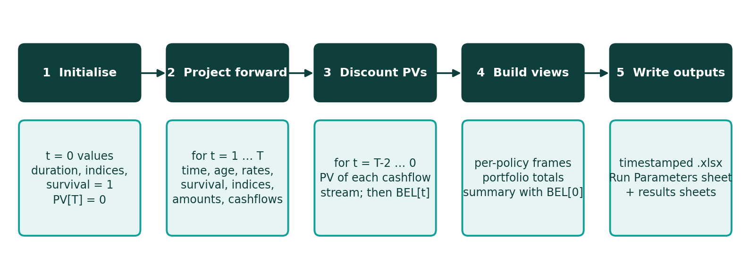
Figure 2. Stages of a single run
- Initialize. Sets the starting position at the valuation date for every policy.
- Project forward. Steps through each year, updating demographic and economic quantities, then amounts and expected cash flows.
- Discount backward. Works from the end of the projection back to the valuation date, producing present values and the BEL.
Assumption tables are read in a way that keeps a policy running beyond the end of a table on its last value, rather than failing.

7.4 Correspondence with the Excel benchmark
Table 13. Equivalent constructs
Concept | Excel benchmark | Python engine
Policy selection | One sheet per policy | One column per policy in each array
Time recursion | Each row builds on the one above | Each step builds on the previous step
Assumption lookup | Lookup functions | Table lookups over all policies at once
Conditional logic | Conditional formulas | Boolean masks
Portfolio total | Roll-up over policy sheets | Sum across policies
Projection length | Fixed at 100 years | Set per run

7.5 Output views
The engine produces three views: a policyholder view with the full projection for each policy, an aggregate view with portfolio totals by year, and a summary view listing each policy with its liability at the valuation date.

7.6 Writing the results.
Each view is written to a new, timestamped Excel workbook that starts with a Run Parameters sheet listing the settings of the run, so that a result file always carries the assumptions that produced it. For the policyholder view, the policies to be written are chosen on the Parameters tab and are validated before the run: entries must be whole numbers, refer to policies that exist, and not be repeated.

8. Excel Front-End

8.1 Purpose
Parameters.xlsm is the control panel of the Python model. Analysts maintain assumptions and run settings in a familiar spreadsheet; macros then turn those into the files that the Python engine reads and start the run. No Python knowledge is needed to operate the model.

8.2 Workbook structure
Table 14. Sheets in Parameters.xlsm
Sheet | Content
Parameters | Run definitions in ten columns, run summary counters, action buttons and a color legend.
Assumptions >> | Folder settings, the register of exported files and usage notes.
Yield Curve | Spot rates by term, with forward rates calculated.
Mortality Rate | Male and female mortality by age.
Expenses | Expense assumptions by policy year.
Commission | Commission assumptions by policy year.
Inflation | RPI and CPI by projection year.

8.3 The Parameters tab
The tab is organized in blocks down the left (Run Info, Projection, Stresses, Views, Debug) with one column per run, and action panels on the right.
Table 15. Action panels and buttons
Panel | Control | What it does
Model Run | Export Config (JSON) | Write the run configuration to a file for the Python engine.
Model Run | Run Model | Launches the Python engine in its virtual environment.
Assumption Loader | One button per assumption tab | Copies that tab, values only, into its CSV file.
Assumption Loader | Generate CSVs | Exports all five assumption tabs in one step.
Run Summary | Counters | Number of active runs, and how many have debug, aggregate, and summary views on.
Legend | Color key | Run on, greyed out, blue text (input), black text (formula).
The tab guides the user visually. A run whose Run Flag is FALSE is greyed out, and the debug policy cells are greyed out for any run whose Debug view is FALSE, so that it is always clear which settings are live.

8.4 Assumption export
The Assumptions >> tab controls where files are written: a root folder (defaulting to the folder containing the workbook, with an optional user override) and an input sub-folder. It also keeps a register of the five assumption files and the configuration file, recording the time of the last export, the number of rows and a status for each, which helps to confirm that the files the Python engine will read are current.

8.5 Run configuration file
Export Config (JSON) writes the run block of the Parameters tab (all ten runs) to a configuration file with one block per run and the parameter names as keys. Blank cells are left out. The Python engine reads this file to learn which runs are active, how they are stressed and which outputs they require.

8.6 Running the model.
Run Model starts the Python engine in its own virtual environment so that the model's package versions are independent of the rest of the machine. For each run whose Run Flag is on, the engine applies the stresses, projects the portfolio, and writes the requested views, reporting each file written.

9. Model Outputs

9.1 Overview of output views
Each run can produce up to three result workbooks, chosen on the Parameters tab. They are designed to answer questions at three levels of detail.
Table 16. Output views
View | File prefix | Level of detail | Typical use
Debug | debug_ | One sheet per selected policy, every projected variable by time step | Tracing a policy line by line; reconciling to the Excel benchmark; teaching
Aggregate | aggregate_ | One sheet with portfolio totals by time step | Cash flow and BEL run-off profile of the whole portfolio
Summary | summary_ | One row per policy: inputs plus BEL at the valuation date | Headline results: comparing policies and runs

Every workbook begins with a Run Parameters sheet that records the settings of the run (run name, valuation date, horizon, stresses, views, and selected debug policies).

9.2 Illustrative result: BEL by policy
The chart below shows the BEL at the valuation date for each policy of the reference portfolio, using the reference assumptions and no stresses. It illustrates the kind of information the model produces and how the liability varies across policies.
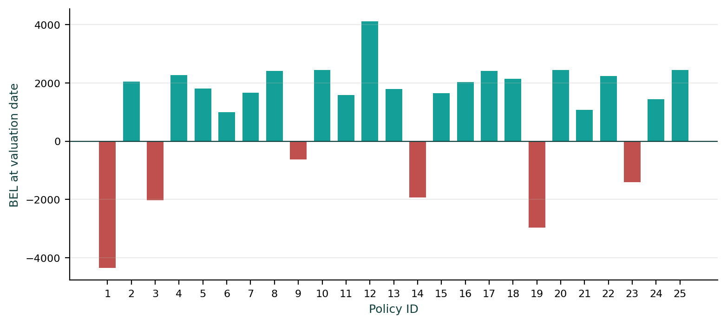
Figure 3. BEL at the valuation date by policy (negative values are shown in red)
Each in-force policy carries a liability that depends on the policyholder's age, sex, remaining term, guarantee, and escalation. Policies written at the valuation date can show a negative BEL where the premium received exceeds the discounted value of the benefits and costs that follow.

10. Controls, Validation and Governance

10.1 Controls built into the model
Table 17. Built-in controls
Control | Where | Purpose
Run and view switches | Parameters tab | Only runs and views that are switched on are executed; others are visibly greyed out.
Debug policy validation | Output module | Rejects entries that are not whole numbers, refer to non-existent policies, or are repeated.
Undefined values left as $NaN$ | Projection module | Quantities with no meaning at t = 0 cannot be mistaken for zero.
Mortality floor | Projection module | A stressed mortality rate can never fall below zero.
Clipped lookups | Projection module | Assumption lookups beyond the end of a table use its last value instead of failing.
Export register | Assumptions >> tab | Records time, row count, and status of each exported file.
Run Parameters sheet | All output workbooks | Every result file records the settings that produced it.
Timestamped file names | Output module | Results are never silently overwritten, and runs can be told apart.
Color legend | Both workbooks | Separates inputs (blue) from formulas (black).

10.2 Reconciliation to the Excel benchmark
The Excel benchmark is an independent check on the Python engine. A reconciliation should be performed whenever the Python code, the assumptions format or the policy data format changes. The recommended procedure is:
- Align the inputs. Use identical policy data, assumptions, valuation date, and horizon in both tools, with all stresses set to zero.
- Compare policy BELs. Compare the BEL of each policy in the summary view with the corresponding Excel policy sheet.
- Compare the portfolio. Compare the total summary view, and the aggregate view by time step, with the Portfolio sheet.
- Investigate differences. Where a policy differs, compare its debug sheet with the Excel policy sheet; the first quantity and time step at which they diverge identifies the cause.
- Repeat under stress. Apply the same stress in both tools (using the stress inputs of the benchmark).
- Record the outcome. Document the tolerance applied, the results and any explained differences (see Section 11).

10.3 Reasonableness checks
- Cumulative survival should start at 1 and fall steadily; it should be negligible by the end of the horizon.
- New business should show a negative BEL when the premium exceeds the value of benefits; in-force policies should show a positive BEL.
- A mortality stress or an interest stress should normally increase the BEL of an annuity portfolio.
- A policy with zero guarantee and zero survival benefit should show only life-contingent payments.
- Cash flows should be zero after the end of the policy term.

10.4 Governance
- Ownership. The model owner is responsible for the assumptions, the code, and the documentation, and for approving changes.
- Change control. Changes to assumptions, policy data or code should be recorded, reconciled to the benchmark, and dated in the revision history of this document.
- Run records. The run name, date and output file names of each reported result should be retained so that any figure can be reproduced.
- Access. Access to the model files is controlled by the model owner.

11. Limitations and Reviewer Notes
No model is a complete description of reality. This section lists the simplifications built into the model and a small number of implementation observations that reviewers should be aware of. Items marked as observations are points to confirm during reconciliation rather than known errors.

11.1 Modelling simplifications
Area | Simplification | Implication
Time step | Annual projection: cash flows occur at year boundaries. | Intra-year timing of payments and deaths is not modelled.
Scenarios | One deterministic best-estimate path plus deterministic stresses. | No stochastic distribution of outcomes.
Premium | Single premium at policy duration 1. | Regular premium contracts are not represented.
Reference data | The reference portfolio and assumption tables are illustrative. | Replace with approved data before using results for reporting.
Units | Excel sheets are labelled in thousands (000s). | Confirm that input data and Python outputs use the same units.
Capacity of the benchmark | 25 policies, 100 years, 6 expenses and commission years. | Larger portfolios and longer horizons are run in Python only.

11.2 Points to note when using the model.
Topic | Note | Suggested action
Projection horizon | A run whose Max Period is shorter than the run-off of the portfolio omits later cash flows. | Choose Max Period so that survival is negligible at the horizon.
Stress sign convention | Positive stress values reduce rates (adverse for annuities). | Use negative values to increase mortality or interest rates.
Assumption tables | Values beyond the last term, age or policy year use the last row. | Ensure tables extend far enough for the intended horizon.

Appendix A. Glossary
Term | Definition
Annuity | A contract paying a regular income to the policyholder in exchange for a premium.
BEL | Best Estimate Liability: the probability-weighted present value of future cash flows from a set of policies.
CPI / RPI | Consumer Price Index / Retail Price Index: measures of inflation used for expense inflation and annuity escalation.
Duration in force | The number of years a policy has been in force; also, the policy year in the projection.
Escalation | The annual increase applied to the annuity amount.
Forward rate | The interest rate applicable between two future dates, derived from the spot curve.
Guaranteed period | The initial period in which annuity payments are made regardless of survival.
Longevity risk | The risk is that policyholders live longer than expected.
Mortality rate q(x) | The probability that a life aged x dies within one year.
Provisional annuity | Part of the annuity paid only if the policyholder survives.
Spot rate | The annualized interest rate for a deposit from today to a given term.
Survival probability | The probability that the policyholder is alive at a given time.
Stress | A deterministic adjustment applied to an assumption to measure sensitivity.
Valuation date | The date at which the liability is measured; time zero of the projection.

Appendix B. Reference Portfolio
The 25 policies of the reference portfolio, as held in Data in Annuity.xlsm. Escalation basis: L = level, R = RPI, C = CPI.
ID | Age | Sex | Premium | Annuity | Term | Dur. IF | Survival. benefit | Guar. period | Infl. | Esc. | Esc. rate
1 | 65 | M | 5560 | 58 | 25 | 0 | 10800 | 10 | RPI | R | 1%
2 | 68 | F | 3812 | 89 | 25 | 5 | 13700 | 0 | RPI | C | 5%
3 | 58 | F | 3721 | 50 | 100 | 0 | 14200 | 12 | RPI | R | 1%
4 | 45 | M | 5151 | 55 | 39 | 8 | 11400 | 1 | CPI | L | 5%
5 | 59 | M | 3383 | 98 | 40 | 11 | 11000 | 5 | CPI | C | 0%
6 | 67 | M | 5002 | 71 | 35 | 11 | 12100 | 2 | RPI | R | 1%
7 | 48 | M | 4585 | 74 | 100 | 9 | 11600 | 15 | CPI | L | 2%
8 | 46 | M | 4325 | 74 | 36 | 5 | 13500 | 0 | CPI | L | 3%
9 | 54 | M | 3042 | 79 | 33 | 0 | 14200 | 4 | RPI | L | 0%
10 | 52 | M | 4242 | 79 | 31 | 8 | 11700 | 4 | CPI | L | 0%
11 | 61 | M | 4138 | 91 | 100 | 10 | 10500 | 2 | CPI | L | 3%
12 | 47 | F | 5915 | 75 | 27 | 7 | 12900 | 4 | RPI | L | 5%
13 | 55 | F | 4213 | 54 | 34 | 9 | 14600 | 0 | CPI | L | 0%
14 | 49 | M | 4096 | 64 | 100 | 0 | 10300 | 0 | CPI | L | 2%
15 | 63 | M | 3635 | 98 | 32 | 10 | 12400 | 5 | RPI | R | 3%
16 | 51 | M | 3075 | 57 | 37 | 8 | 14000 | 10 | CPI | C | 1%
17 | 57 | F | 5111 | 59 | 28 | 7 | 10700 | 2 | CPI | R | 5%
18 | 45 | F | 4063 | 99 | 100 | 11 | 13200 | 2 | CPI | L | 3%
19 | 66 | F | 5484 | 77 | 23 | 0 | 10000 | 4 | CPI | L | 0%
20 | 53 | F | 4482 | 96 | 35 | 9 | 11900 | 0 | RPI | L | 2%
21 | 60 | M | 4996 | 53 | 100 | 8 | 12700 | 5 | CPI | L | 1%
22 | 46 | M | 4613 | 81 | 38 | 10 | 10200 | 5 | CPI | L | 0%
23 | 56 | M | 5476 | 96 | 26 | 0 | 13900 | 4 | CPI | L | 5%
24 | 64 | M | 3892 | 97 | 39 | 11 | 11300 | 1 | RPI | R | 3%
25 | 50 | F | 4288 | 63 | 34 | 6 | 14500 | 1 | RPI | C | 0%

----- End -----

